**LOGISTIC REGRESSION CLASSIFIER**

Logistic regression is a statistical technique used for classification in supervised machine learning. When the data to be analyzed has a binary output, that is, it either belongs to one of two classes (0 or 1), logistic regression is commonly used.

It's important to note that logistic regression should only be used when the target variables are discrete, and that if the target value is in a set of continuous values, logistic regression should be avoided.

When using logistic regression, a threshold is typically defined, indicating at what value the example will be assigned to one of two classes.

**Algorithm for Logistic Regression**

The **Sigmoid function** is used in Logistic Regression to deal with outliers.

The basic logistic function can be used to begin a discussion of logistic regression. The logistic function is a Sigmoid function that accepts any real value between 0 and 1 as input. It's defined as:

$y=1/(1+e^{-x}$**)**

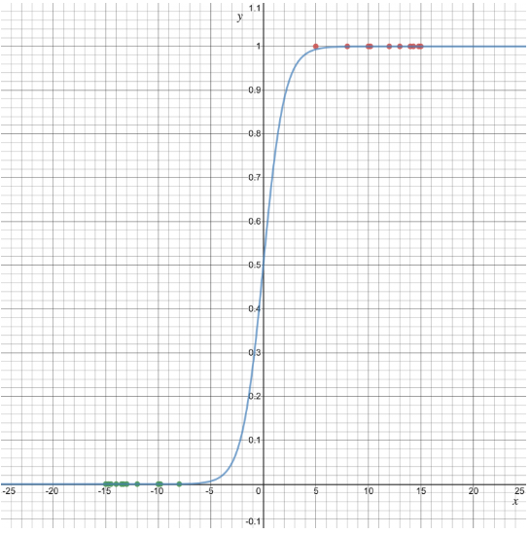As shown in the diagram, the sigmoid function represents the given dataset:

**Source:** https://kambria.io/blog/logistic-regression-for-machine-learning/

**Applications of Logistic Regression:**

It is essential to understand that logistic regression should only be used when the target variables fall into discrete categories, and that logistic regression should not be used if the target value falls into a range of continuous values. The following are some scenarios in which logistic regression might be useful:

* determining whether or not an email is spam
* Whether a tumor is cancerous or benign
* To determine whether a mushroom is poisonous or edible.